Golden Rules for Low Latency

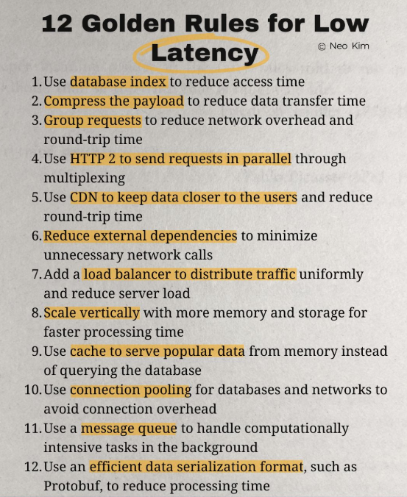

- Use database index to reduce access time
- Compress the payload to reduce data transfer time
- Group requests to reduce network overhead and round-trip time
- Use HTTP 2 to send requests in parallel through multiplexing
- Use CDN to keep data closer to the users and reduce round-trip time
- Reduce external dependencies to minimize unnecessary network calls
- Add a load balancer to distribute traffic uniformly and reduce server load
- Scale vertically with more memory and storage for faster processing time
- Use cache to serve popular data from memory instead of querying the database
- Use connection pooling for databases and networks to avoid connection overhead
- Use a message queue to handle computationally intensive tasks in the background
- Use an efficient data serialization format, such as Protobuf, to reduce processing time

Golden Rules for Low Latency in detail with examples:
1. Use database index to reduce access time
- An index is like a table of contents for your database. Instead of scanning the entire table, the database jumps directly to the required row.
- Example: Searching for customer_id=123 in a table of 1M rows is instant with an index, but takes seconds without one.

2. Compress the payload to reduce data transfer time
- Compressing responses (e.g., Gzip, Brotli) makes data smaller, reducing transfer time.
- Example: A 2MB JSON response compressed to 200KB downloads much faster over the network.

3. Group requests to reduce network overhead and round-trip time
- Instead of making many small requests, group them into fewer, larger requests.
- Example: Instead of fetching 10 API responses separately, batch them into one request.

4. Use HTTP/2 to send requests in parallel through multiplexing
- HTTP/2 allows multiple requests over a single TCP connection.
- Example: Loading 50 images on a webpage is faster with HTTP/2 than opening 50 separate TCP connections (HTTP/1.1).

5. Use CDN to keep data closer to the users
- A Content Delivery Network stores cached copies of files in edge servers across the world.
- Example: A user in India gets website content from a nearby server in Mumbai instead of the origin server in the US.

6. Reduce external dependencies to minimize unnecessary network calls
- Every external API call adds latency. Minimize them when possible.
- Example: Instead of calling a 3rd-party service for currency conversion repeatedly, cache the rates and update periodically.

7. Add a load balancer to distribute traffic uniformly and reduce server load
- A load balancer spreads requests across multiple servers to avoid bottlenecks.
- Example: If one server is overloaded, requests are automatically routed to a less busy one.

8. Scale vertically with more memory and storage for faster processing time
- Vertical scaling means upgrading a single server (more CPU, RAM, SSD).
- Example: A database query that takes 2 seconds on 8GB RAM might complete in 0.5 seconds on 64GB RAM.

9. Use cache to serve popular data from memory instead of querying the database
- Cache (Redis, Memcached, in-memory cache) stores frequent results for quick retrieval.
- Example: Instead of querying product details for every user request, fetch them from cache.

10. Use connection pooling for databases and networks to avoid connection overhead
- Opening/closing a DB connection for each request is slow. A connection pool reuses open connections.
- Example: JDBC connection pooling reduces query latency by avoiding repeated handshakes.

11. Use a message queue to handle computationally intensive tasks in the background
- Offload long-running tasks to asynchronous workers using a queue (Kafka, RabbitMQ, SQS).
- Example: Sending an email after user registration should be queued, not block the user response.

12. Use an efficient data serialization format, such as Protobuf, to reduce processing time
- JSON and XML are human-readable but heavy. Protobuf/Avro/MessagePack are faster and smaller.
- Example: A 10KB JSON object might shrink to 2KB with Protobuf and parse faster.

